Spring REST - Country Web Service

Project Structure
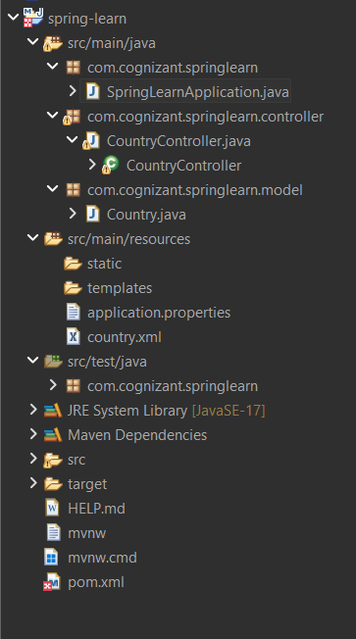

Country.java
package com.cognizant.springlearn.model;
public class Country {
private String code;
private String name;
public Country() {}
public Country(String code, String name) {
this.code = code;
this.name = name;
}
public String getCode() { return code; }
public void setCode(String code) { this.code = code; }
public String getName() { return name; }
public void setName(String name) { this.name = name; }
}

country.xml
<?xml version="1.0" encoding="UTF-8"?>
<beans xmlns="http://www.springframework.org/schema/beans"
xmlns:xsi="http://www.w3.org/2001/XMLSchema-instance"
xsi:schemaLocation="
http://www.springframework.org/schema/beans
https://www.springframework.org/schema/beans/spring-beans.xsd">
<bean id="india" class="com.cognizant.springlearn.model.Country">
<property name="code" value="IN"/>
<property name="name" value="India"/>
</bean>
</beans>

CountryController.java
package com.cognizant.springlearn.controller;
import org.springframework.context.ApplicationContext;
import org.springframework.context.support.ClassPathXmlApplicationContext;
import org.springframework.web.bind.annotation.GetMapping;
import org.springframework.web.bind.annotation.RestController;
import com.cognizant.springlearn.model.Country;
@RestController
public class CountryController {
@GetMapping("/country")
public Country getCountryIndia() {
ApplicationContext context =
new ClassPathXmlApplicationContext("country.xml");
Country country = (Country) context.getBean("india");
return country;
}
}

application.properties
spring.application.name=spring-learn
server.port=9090

Output
URL:
http://localhost:9090/country
